Wiring Adapters SPI
Version 0.1

Copyright OpenAVRc 2018

1 Document version
Version | Date | Reason for update
0.1 | 11/10/2018 | Creation

2 Copyright
This document is Copyright © 2018 OpenAVRc.

3 Caution
The OpenAVRc team is not responsible for damages that may arise from the misuse or possible malfunction of the OpenAVRc transmitter.
It is therefore up to the end user to measure, assume the risks and comply with the legislation in force depending on the country of use.

4 Table of content

1 Document version 2
2 Copyright 2
3 Caution 2
4 Table of content 3
5 Radio Modules : 4
5.1 Module HF cc2500 yellow: 4
5.2 Module HF nrf24l01 : 5
5.3 Module HF a7105 : 5
5.4 Module HF cyrf6936: 5

5 Modules HF :

5.1 Module HF cc2500 yellow:

If you only use FrSky receivers, prefer the following CC2500 module or equivalent.
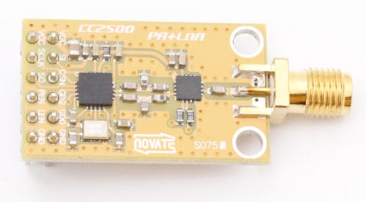

Yellow cc2500 HF Module Wiring :
The input outputs only accept 3.3v signals. It is ESSENTIAL to separate this module from the Core using a 4-channel converter (MOSI, MISO, CS, SCLCK) which receives 0-5v level signals and converts them into 0-3,3v level signals. and vice versa for the MISO signal.
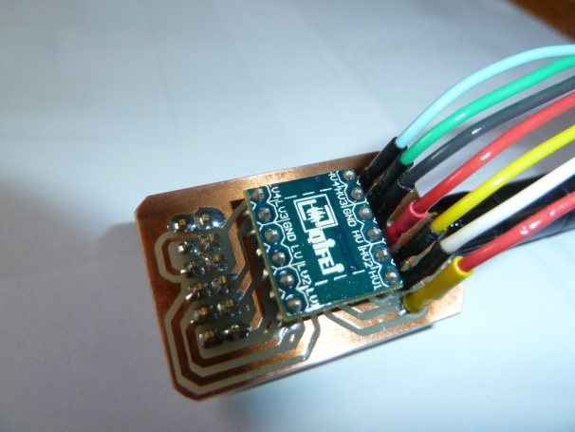
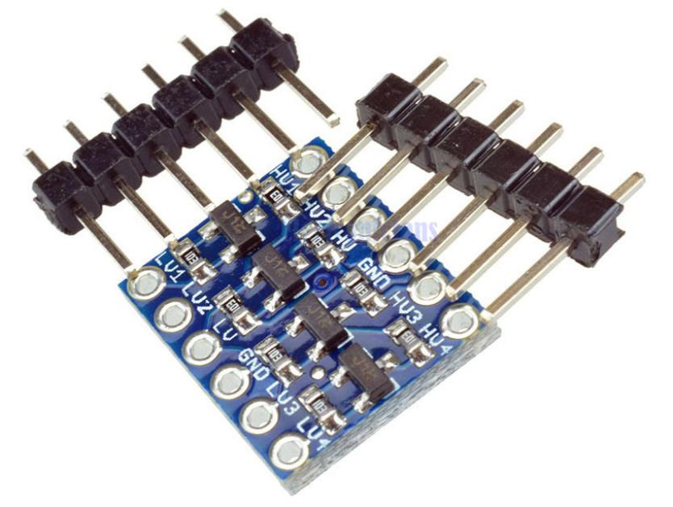

This circuit board will allow adaptation in a reduced format. It is connected to P7 (see p14).
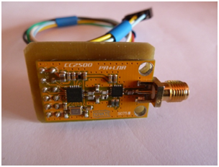
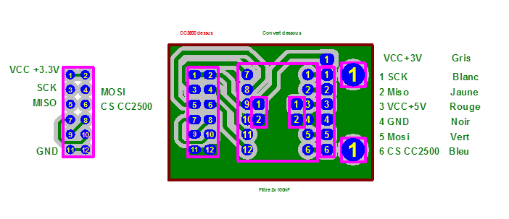

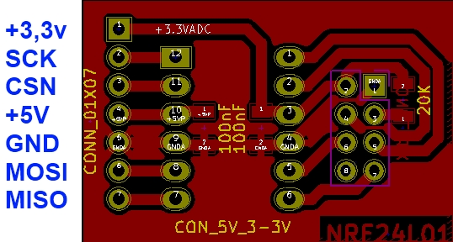
5.2 Module HF nrf24l01 :

5.3 Module HF a7105 :
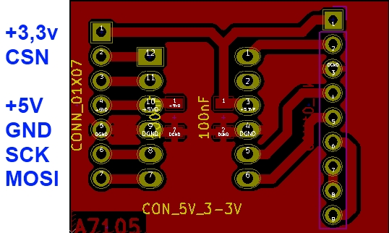

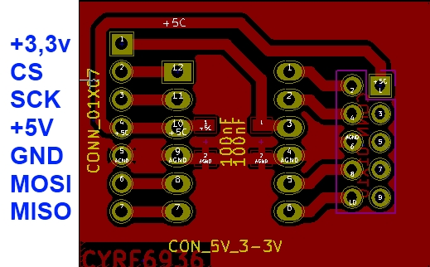
5.4 Module HF cyrf6936:

